Service job
Customer Pricing Master: x
- Option to edit / add the job category. Please create a reference table for Job Category

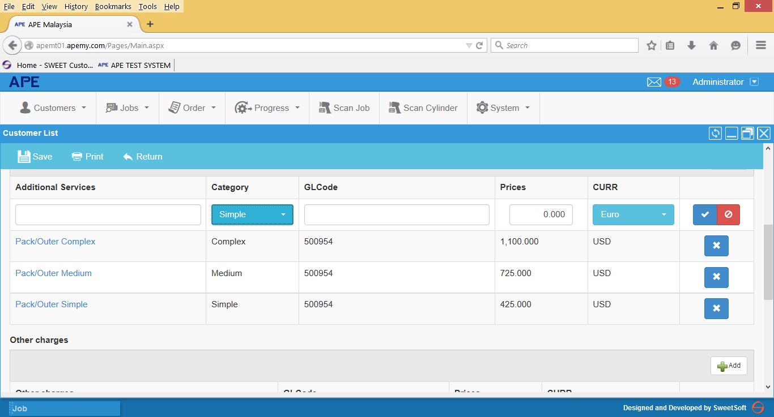

Service Job creation
- Payment terms should be automatically captured from Customer Master payment terms.

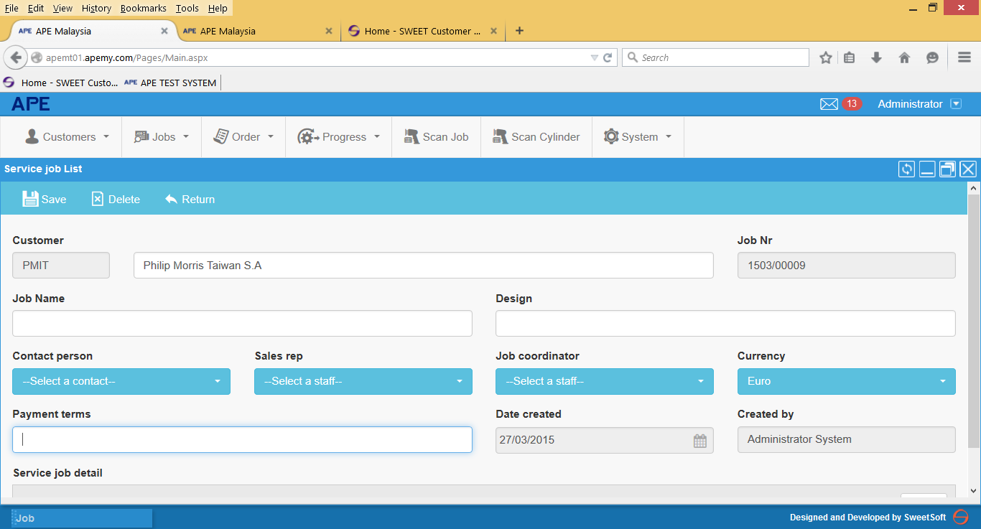
Order Confirmation
Need to create separate OC template for Service Job.
- Alignment for terms of payment and terms of delivery
- Alignment for Job Name and Design Name
- Job Header →Please follow the header in the invoice. i.e.
- No
- Work Order No
- Product ID
- Description
- Job category ( not needed in Invoice ) only on OC
- Tax Code
- Tax Rate
- Work Order Value
- Add Job category after description column.
- Job category only appeared in Order Confirmation print-out but not in Invoice

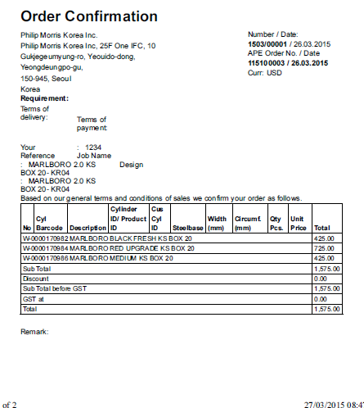

Service Job
Invoice
- Remove Title – Service Job
- Add column APE Order no/ Date below Invoice No and Date.
- Description column – make a bigger space.
- Tax code and Tax rate column: Smaller size

